UNIT 2: SCHOOL
Period 9: LESSON 1
Date of preparation: September 19th , 2022
Date of teaching: September 23rd, 2022
Class: 6A3
I/ AIMS AND OBJECTIVES:
+ Language content : - To introduce ss some new words which related to school subjects.
- To help ss know school subjects
- To help ss improve their speaking skill.
- To help ss listen for specific information and help ss improve their listening skill
+ Language function : _By the end of the lesson, the students will be able to :
+ know school subjects.
+ understand the listening and fill in the blanks.
+ Educational aim : - To make the students know school subjects.
1.Language:
+Vocabulary :
1. (school) subject (n) /skuːl ˈsʌbdʒekt/
2. math = mathematics (n) /ˌmæθəˈmætɪks/
- literature (n) /ˈlɪtrətʃər/
- history (n) /ˈhɪstri/
- geography (n) /dʒiˈɒɡrəfi/
- physics (n) /ˈfɪzɪks/
- biology (n) /baɪˈɒlədʒi/
- science (n) /ˈsaɪəns/
- music (n) /ˈmjuːzɪk/
- art (n) /ɑːrt/
- P.E = physical education (n) /ˌfɪzɪkl edʒuˈkeɪʃn/
12.I.T = Information Technology (n) /ˌɪnfəˌmeɪʃn tekˈnɒlədʒi/ :
+Structures : “How about you?
What do you think?”
2.Skills: , Speaking, Listening,Reading,Writing
3. Educational factor: _Knowing to talk about school subjects.
II/TEACHER’S AND STUDENTS’ PREPARATIONS:
1.Method: Communicative Approach
2.Techniques : pairwork, explanation, repetition, completion, game, groupwork
3. Materials needed : charts , tape, cassette recorder
4. Students’ preparations : school things , preparation “LESSON 1”
5.Previous exercise : the homework
III/PROCEDURES IN CLASS:
1. Stabilization: -Greets the students
(1 minute) -Checks the attendance
2. Checking –up the previous knowledge : No checking
3.New lesson:

Teacher’s activities | Students’  activities | The lesson content
I/ WARM UP:  -Play game: Unscrambled Words  - Shows 5 secrete boxes and introduces the rules of game to Sts.  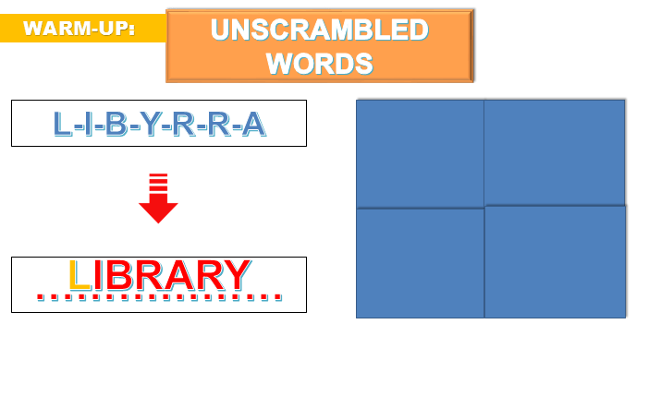  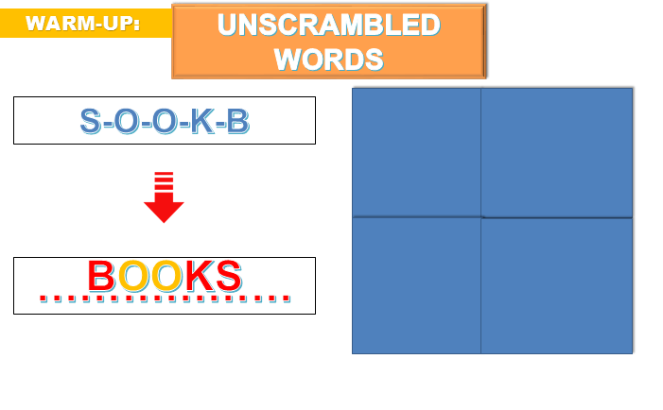  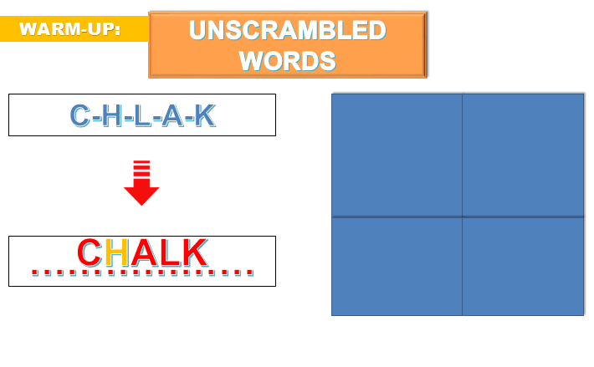  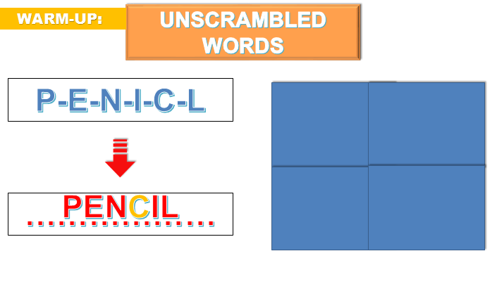  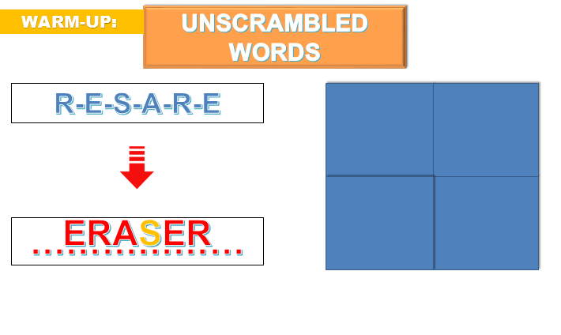  1. Rearrange the letters to be a correct words  2. Answer the question  3. If you are correct you will be given a gift  4. If you are incorrect you will loose your turn  II/ PRE –PRACTICE:  - Shows five pictures .  - Introduces the aim of the lesson  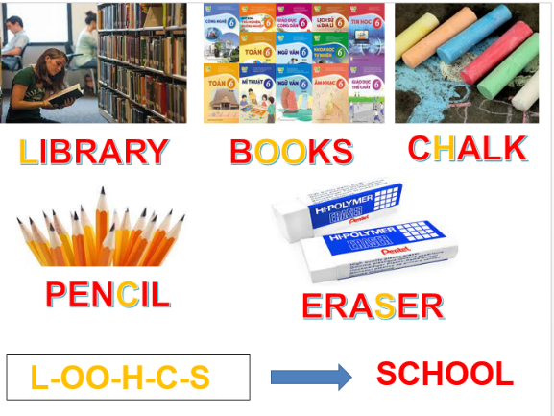  UNIT 1: SCHOOL ( Lesson1)  III/ WHILE–PRACTICE:  - NEW WORDS:  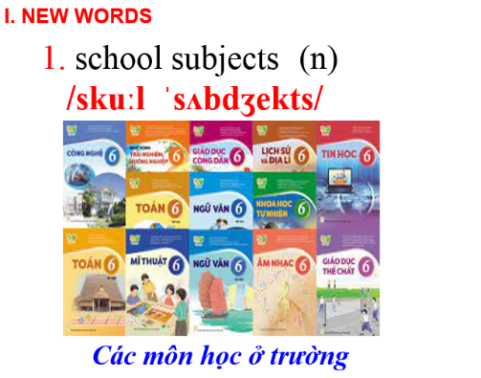  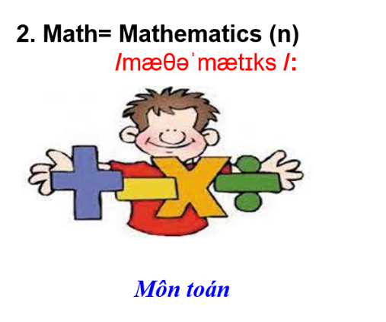  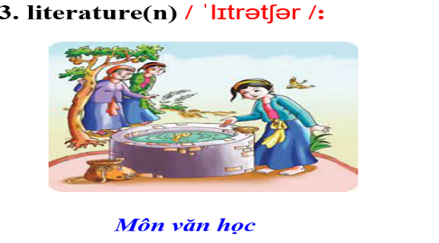  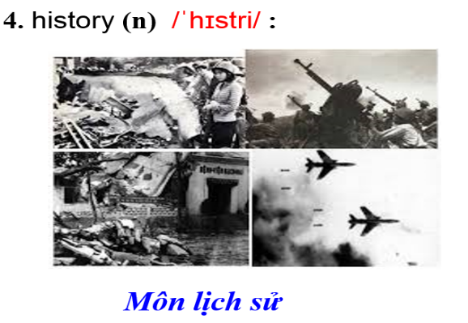  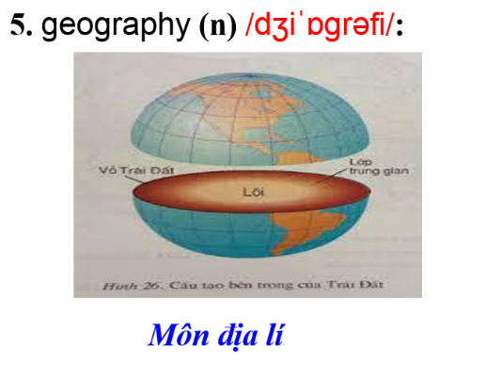  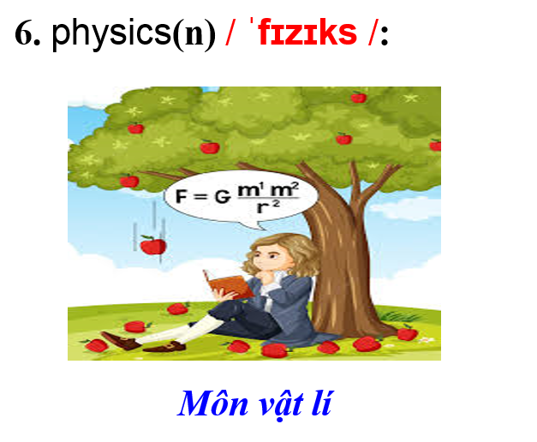  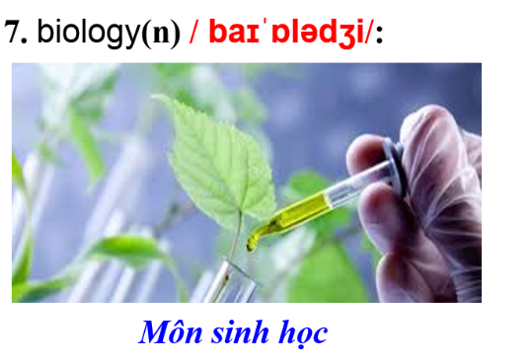  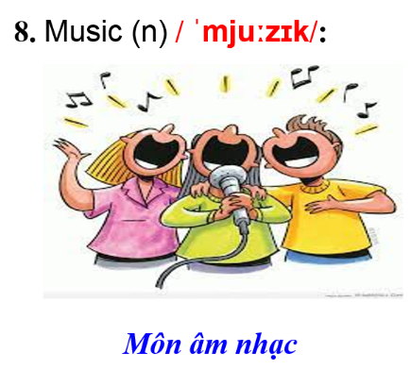  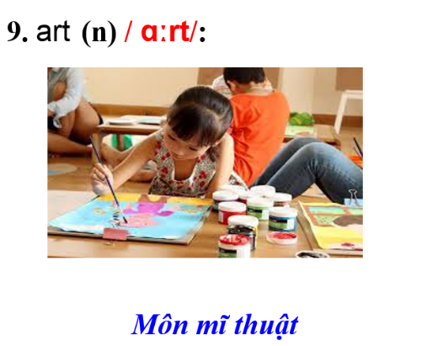  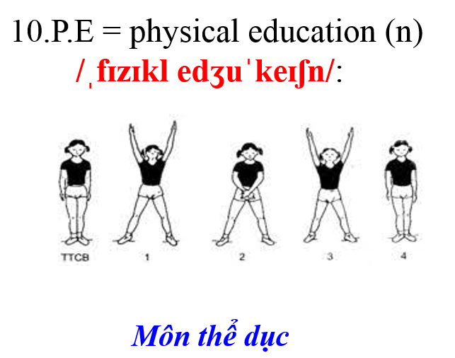  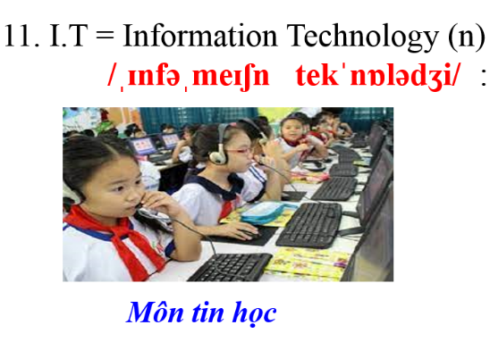  - Shows the sentences and pictures related to new words.  - Opens audio twice  - Calls some students stand up and repeat.  * Checking new words  - a. Match each phrase to each picture.  1. Biology  2. Physics  3. History  4. Music  5. Literature  6. Geography  7. IT  8. P.E (physical education)  b. Work in pairs.  Note three more subjects you know. Discuss if you like them.  A: Do you like math?  B: Yes, I do.  I study math on Monday,..  - LISTENING:  Answer the question  a.Listen to Adrian and Sarah talking about school subjects.  Who likes more school subjects?  -Opens the audio once  *Answer: Sarah  - Adrian likes _________  - Sarah likes history, physics and _______  - Sarah doesn’t like _____________  - Adrian’s favorite subject is __________  - Asks sts to listen and fill in the blanks.  -Opens the audio twice  3. PRACTICE:  -Asks students to practice the conversation.  Work in pairs. Practice passing your turn.  “How about you?  What do you think?”  IV/ POST–PRACTICE:  -Asks sts to do exercises  1. I like ________ because I like reading stories  A. physics B. math  C. literature D. history  2. I like to learn about plants and how they grow. I like _____  A. I.T B. biology C. history D. geography  3. I like computers. That’s why I like _______  A. P.E B. I.T  C. history D. geography  4. I love to learn about mountains and rivers. I like _______  A. I.T B. physics  C. math D. geography  5. I don’t like running and playing sports. I don’t like ______  A. literature B. P.E  C. math D. history  6. Studying _______ helps me learn about countries around the world and famous people in the past.  A. I.T. B. P.E.  C. physics D. history  7. I love to learn how light, heat, and sound work. I love _____  A. geography B. biology  C. physics D. P.E.  V/CONSOLIDATION:  _Reminds what they have learnt.  VI. HOMEWORK  _Asks the students to learn the vocabulary by heart  - Practice the conversation at home.  - Prepare new lesson : Unit 2- Lesson 1(cont) | - Listen  - Look at and rearrange the letter.  -Listen to the teacher and play games.  - Listen and answer  - Listen and copy down.  - Listen and copy down.  -Listen and answer  -Listen and repeat  -Stand up and repeat.  -work in pairs  - Work in pairs and answer  -Listen  - Listen and answer  -Listen and fill in the blanks.  - Listen  -Practice the conservation  -Do execise  -Listen  -Listen and copy down. | UNIT 2: SCHOOL (Lesson 1)  I. NEW WORDS  1. (school) subject (n) /skuːl ˈsʌbdʒekt/  2. math = mathematics (n) /ˌmæθəˈmætɪks/  3.literature(n) /ˈlɪtrətʃər/  - History (n) /ˈhɪstri/  - geography(n)  /dʒiˈɒɡrəfi/  - physics(n) /ˈfɪzɪks/  - biology (n) /baɪˈɒlədʒi/  - science (n) /ˈsaɪəns/  - music (n) /ˈmjuːzɪk/  - art (n) /ɑːrt/  - P.E = physical education (n) /ˌfɪzɪkl edʒuˈkeɪʃn/  12.I.T = Information Technology (n) /ˌɪnfəˌmeɪʃn tekˈnɒlədʒi/ :  * Checking new words  - a. Match each phrase to each picture.  1. Biology  2. Physics  3. History  4. Music  5. Literature  6. Geography  7. IT  8. P.E (physical education)  b.Work in pairs.  A: Do you like math?  B: Yes, I do.  I study math on Monday,..  II. LISTENING:  a. Answer the question  *Answer: Sarah  b.Fill in the blanks:  1. art.  2. P.E.  3. geography.  4. P.E.  III. PRACTICE:  Mary:I like studying biology. How about you?  Tom: I love physics.  What do you think?  Tim: I like English.  IV. EXERCISE:  - C  - B  - B  - D  - B  - D  - C  *HOMEWORK:  Asks the students to learn the vocabulary by heart  - Practice the conversation at home.  - Prepare new lesson : Unit 2- Lesson 1(cont)
*SELF- EVALUATION:
………………………………………………………………………………………………………………………………………………………………………………………………………………………………………………………………………………………………………………………………………………………………………………………………………………………………

